 **TECHNOLOGICAL UNIVERSITY OF THE PHILIPPINES**

**TAGUIG CAMPUS**

Km. 14 East Service Road Western Bicutan Taguig City 1630

TUP-T COVID 19 CONTACT TRACING DATABASE SYSTEM

**CASE STUDY TITLE**

**Year/Level :**

BSIT-NS-1A-T

**Submitted by :**

Fabros, John Heinrich L.

Aldwin Zed Gatpo

**ABOUT COVID-19**

We all know that Covid-19 caused economic and social disruption in tens of million of people are at risk of falling into extreme poverty, While the number of undernourished people, currently estimated at nearly 690 million, could increase by up to 132 million by the end of the year.

As the coronavirus pandemic rapidly sweeps across the world, it is inducing a considerable degree of fear, worry and concern in the population at large and among certain groups in particular, such as older adults, care providers and people with underlying health conditions.

In public mental health terms, the main psychological impact to date is elevated rates of stress or anxiety. But as new measures and impacts are introduced – especially quarantine and its effects on many people’s usual activities, routines or livelihoods – levels of loneliness, depression, harmful alcohol and drug use, and self-harm or suicidal behaviour are also expected to rise.

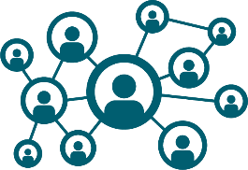

**ABOUT CONTACT TRACING**

One of the most important public health interventions to prevent the spread of COVID-19 is CONTACT TRACING. It identifies the person who may have close contact with a person with COVID-19. It subsequent collection of further information about these close contacts

The COVID-19 epidemic is still spreading globally. Contact tracing is a vital strategy in epidemic emergency management; however, traditional contact tracing faces many limitations in practice. The application of digital technology provides an opportunity for local governments to trace the contacts of individuals with COVID-19 more comprehensively, efficiently, and precisely

**DETECTING | REPORTING | ISOLATING | TREATING**

Public health aims to reduce transmission of infections in the population

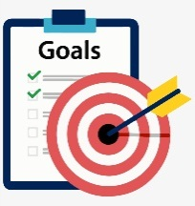

**GOALS OF CONTACT TRACING**

Our research aimed to provide new solutions to overcome the limitations of traditional contact tracing by introducing the organizational process, technical process, and main achievements of digital contact tracing.

1. **Interrupt ongoing transmission and reduce spread of an infection**
2. **Establish epidemiological link or track the sources of infection and contain further spread**
3. **Aleart contacts to the possibility of infection and ensure timely referral for management and care**
4. **Provide diagnosis, Health education and psychosocial support, and treatment to those who have COVID-19**
5. **Help prevent re-infection in a person previously treated of COVID-19**
6. **Learn about the epidemiology of COVID-19**

**CONTACT MONITORING**

* **Conducting daily monitoring of close contacts for 14 days**
* **Accomplishing recording forms and submit to health office at the end of each day**
* **Facilitating transport for immediate referral of contacs who are symptomatic for appropriate assessment and management**
* **Providing health education and giving instructions about what close contacts need to do**
* **Referral to appropriate offices non-health concerns/issues of close contacts**
* **Submitting accomplished form to local health office**

**ABOUT THE DATABASE SYSTEM.**

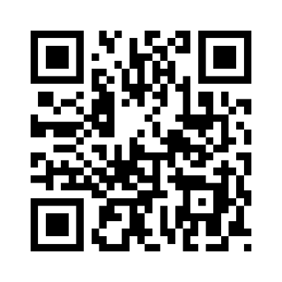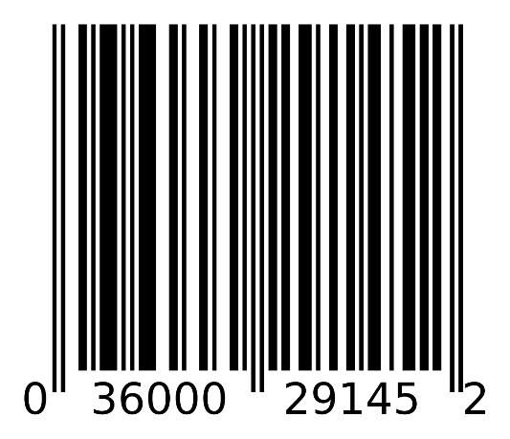**In this TUPT COVID 19 DATABASE SYSTEM. It generates a lot of a thing including the most efficient way to track the infected person through their QR/BAR code or their specific code each person. It will also saves a lot of time configuring out than doing paper by paper just to track which or where department or building did they go. It will also establish their link or track the sources of infection and contain further spread of the virus inside the campus.**

**Conclusions**

During the emergency management of the COVID-19 epidemic, used a graph database algorithm to trace contacts in a centralized model, which can identify infected individuals and high-risk public places more quickly and accurately. This practice can provide support to government agencies to implement precise, agile, and evidence-based emergency management measures and improve the responsiveness of the public health emergency response system. Strengthening data security, improving tracing accuracy, enabling intelligent data collection, and improving data-sharing mechanisms and technologies are directions for optimizing digital contact tracing.

PROS AND CONS OF CONTACT TRACING

The new approach to digital contact tracing provides multiple significant advantages over the global use of conventional contact tracing and alternative methods of digital surveillance.

Digital tracing offers a scalable approach when compared to traditional contact tracing, which is generally based on memories of patients recent exposure to others. As the coronavirus continues to spread throughout the world, traditional efforts to trace contacts are unlikely to continue and definitely require a battalion of healthcare professionals. The current opt-in participation, rotating keys, and short-term data storage offer significantly better confidentiality than most internationally deployed systems.

Potential information gaps that may cause "false positive" alerts include accurate measurement of device distance, exposure duration, and a high probability of such cases where individuals live in highly dense buildings that are only divided by walls. False negatives may also occur in theory if the phone fails to transmit a Bluetooth signal by means of a transmission glitch or if a brief interaction fails to be detected.

Counteracting both privacy and confidentiality concerns as well as unnecessary panic will probably be critical to foster the adoption of a new system, which will have a large and powerful influence on the development of behavioral changes at the societal level.

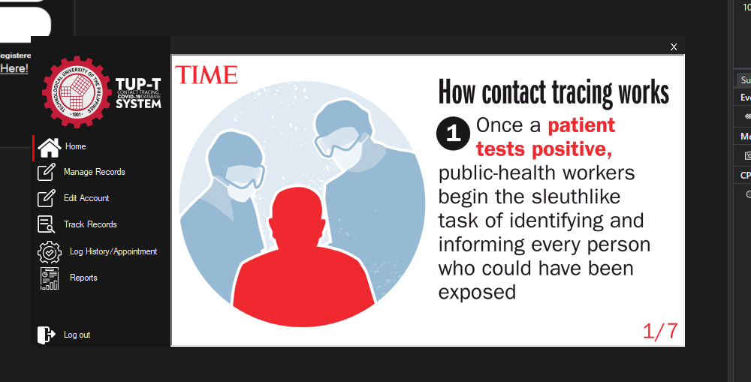**FUNCTIONALITIES**

As a student of Technological University Of The Philippines. I believe that we need this kind of system which we can access easily and with the function of the System is to make the things a lot more easier to see rather than checking it all the Data information of the Users or the People. With this we can more track easily the people who got sick and in the time that they have entered the Campus or whenever Building they are in. It was once tested in just a single paper to write all of the information but thanks to Technology that we have now developed a software that can be used by the Public

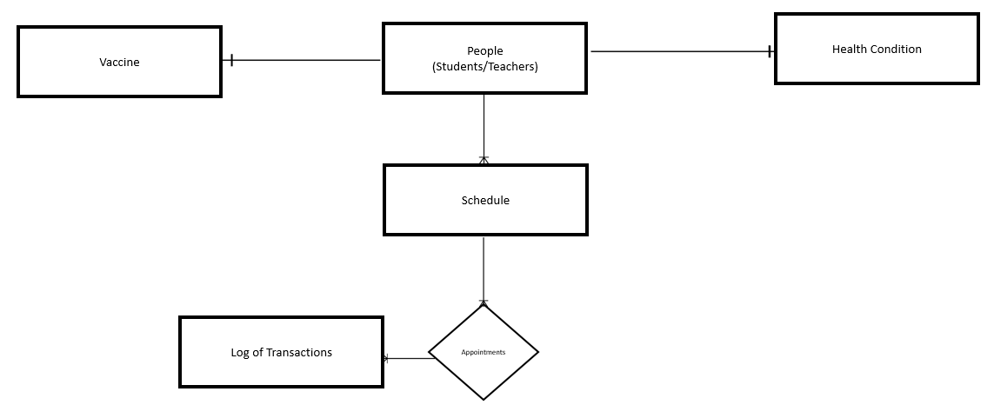**BUSINESS RULE**

RELATIONSHIP MATRIX

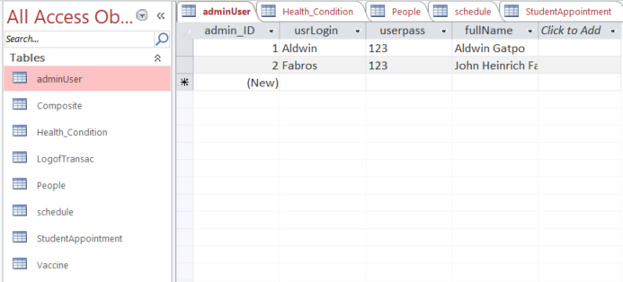

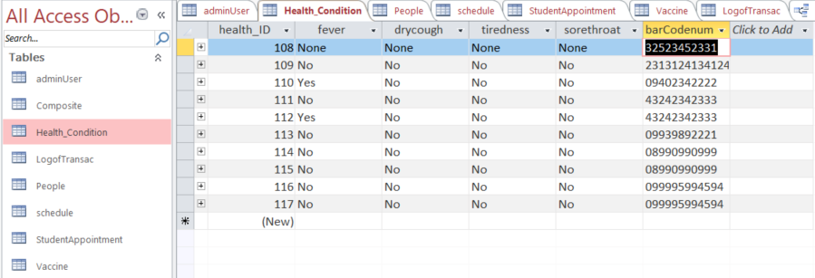

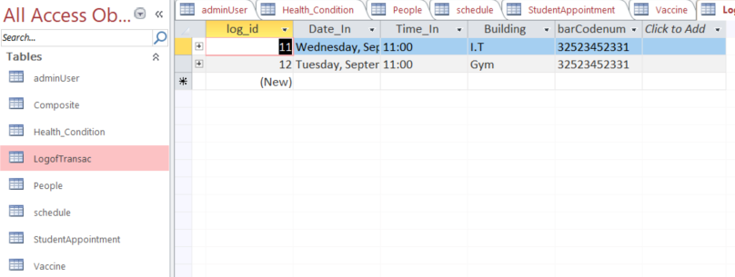

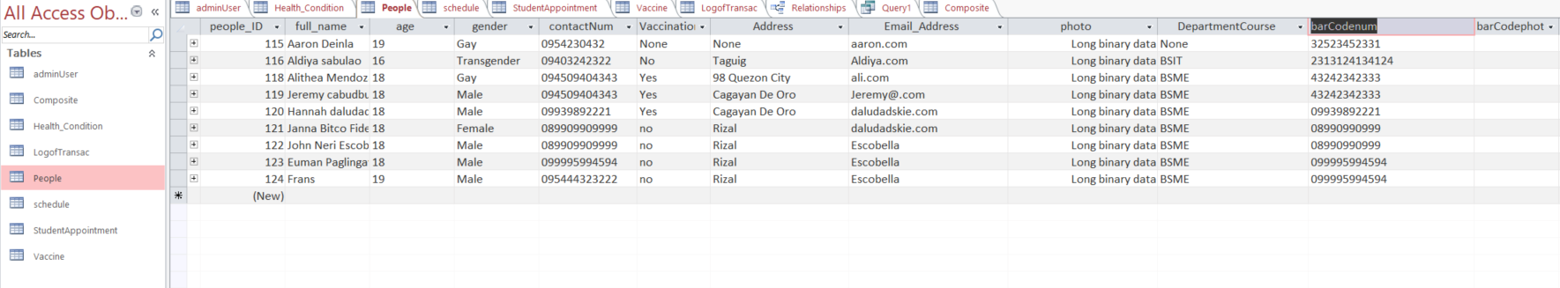

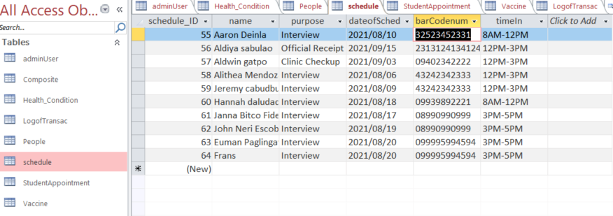

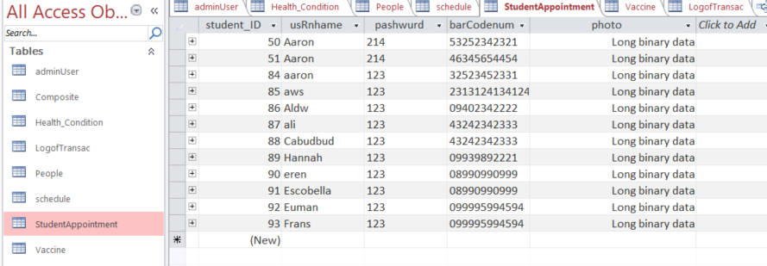

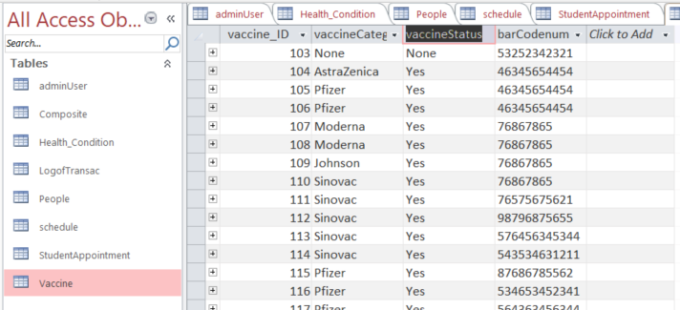

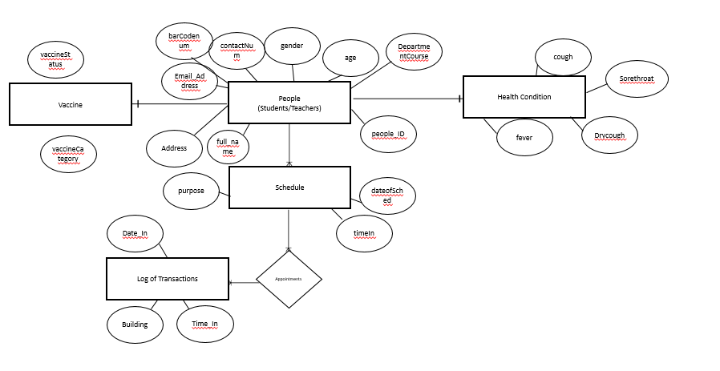COMPLETE ERD DIAGRAM

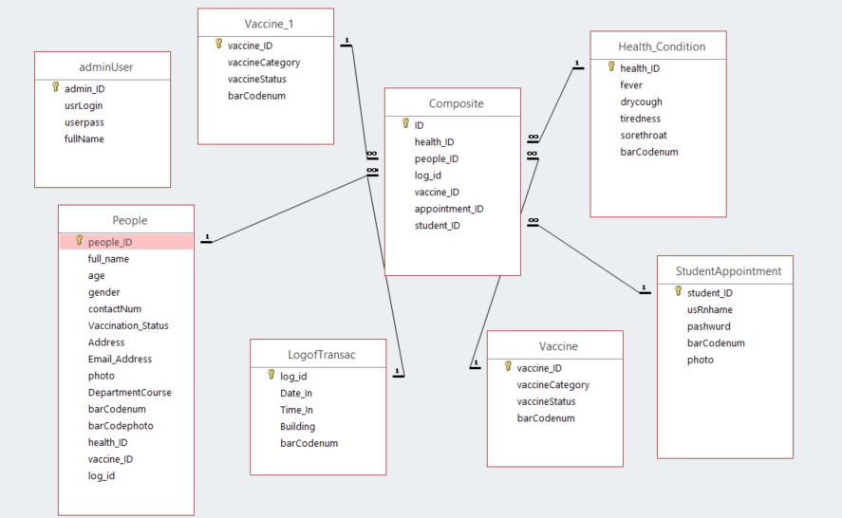DATABASE RELATIONSHIP

LOGIN FORM

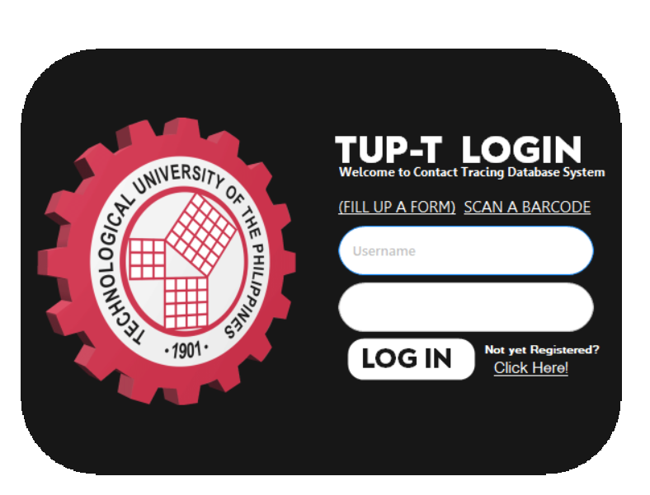On the first part of the System comes with the Login Function the only purpose of this is to evaluate what kind of users we are going to use for example as an Admin user. I will input my Admin username and password as well as the Normal users. In the other side we can see the Fill up form, Scan a Barcode, and Click Here! On this functions it serves as a function for normal users who wants to have an appointment in the School. Scan a Barcode is for the users to but everyone who will go inside the campus or the building,etc .Click here label represents as a User registration for the admin.

Imports System.Data.OleDb

Imports System.Data

Imports System.IO

Public Class guiLogin

Dim mydatarecords As DataTable = New DataTable

Dim sqlString As String = ""

Dim dx As String = ""

Dim sqlx As String = ""

Dim connClass As ConnectToDB = New ConnectToDB

Private Sub BunifuButton1_Click(sender As Object, e As EventArgs) Handles BunifuButton1.Click

Dim cmd As New OleDbCommand("select count(*) from adminUser where usrLogin=? and userpass=?", connClass.conn)

cmd.Connection = connClass.conn

connClass.OpenConnection()

If BunifuTextBox1.Text = Nothing Or BunifuTextBox2.Text = Nothing Then

MsgBox("Enter Credentials", MsgBoxStyle.Exclamation)

Else

Try

cmd.Parameters.AddWithValue("@1", OleDbType.VarChar).Value = BunifuTextBox1.Text

cmd.Parameters.AddWithValue("@1", OleDbType.VarChar).Value = BunifuTextBox2.Text

Dim count = Convert.ToInt32(cmd.ExecuteScalar())

If (count > 0) Then

MsgBox("Log In Succeed", MsgBoxStyle.Information)

AdminForm.Show()

Me.Close()

Else

End If

Catch ex As Exception

End Try

End If

Dim cmd1 As New OleDbCommand("select count(*) from StudentAppointment where usRnhame=? and pashwurd=?", connClass.conn)

cmd1.Connection = connClass.conn

connClass.OpenConnection()

If BunifuTextBox1.Text = Nothing Or BunifuTextBox2.Text = Nothing Then

MsgBox("Enter Credentials", MsgBoxStyle.Exclamation)

Else

Try

cmd1.Parameters.AddWithValue("@1", OleDbType.VarChar).Value = BunifuTextBox1.Text

cmd1.Parameters.AddWithValue("@1", OleDbType.VarChar).Value = BunifuTextBox2.Text

Dim count1 = Convert.ToInt32(cmd1.ExecuteScalar())

If (count1 > 0) Then

MsgBox("Log In Succeed", MsgBoxStyle.Information)

UserForm.sqlString = "SELECT photo FROM StudentAppointment WHERE usRnhame = '" & BunifuTextBox1.Text & "'"

UserForm.sqlString1 = "SELECT barCodenum FROM StudentAppointment WHERE usRnhame = '" & BunifuTextBox1.Text & "'"

UserForm.Show()

Me.Close()

Else

MsgBox("Invalid Data", MsgBoxStyle.Critical)

End If

Catch ex As Exception

End Try

End If

End Sub

Private Sub LinkLabel1_LinkClicked(sender As Object, e As LinkLabelLinkClickedEventArgs) Handles LinkLabel1.LinkClicked

Registry.Show()

End Sub

Private Sub LinkLabel4_LinkClicked(sender As Object, e As LinkLabelLinkClickedEventArgs) Handles LinkLabel4.LinkClicked

scanAbarcode.Show()

End Sub

Private Sub LinkLabel3_LinkClicked(sender As Object, e As LinkLabelLinkClickedEventArgs) Handles LinkLabel3.LinkClicked

RegisterAdmin.Show()

End Sub

End Class

REGISTRATION FORM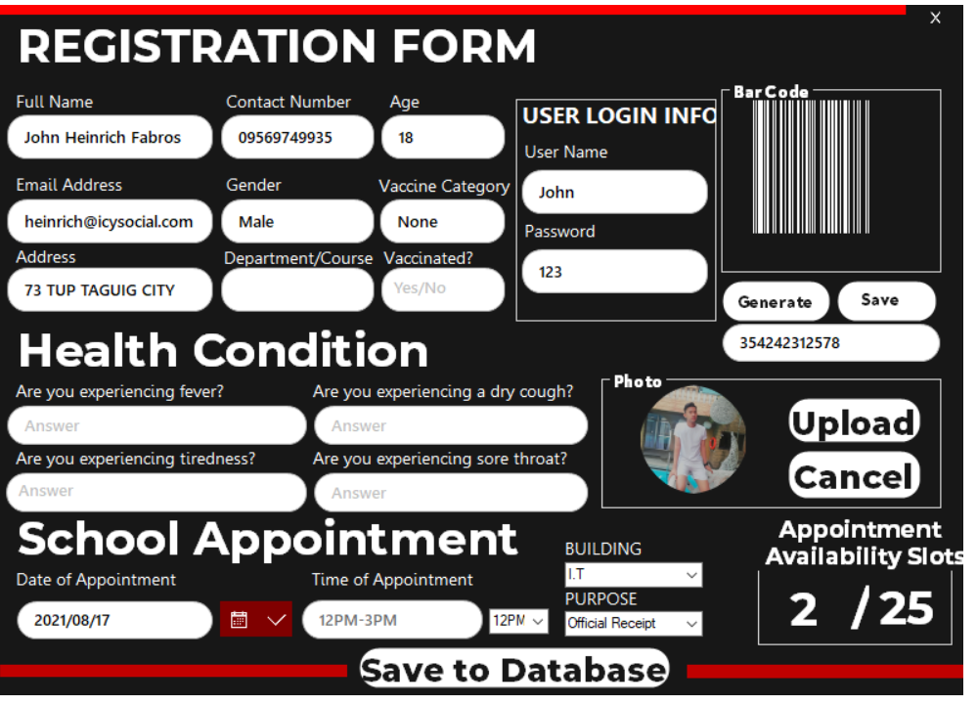

Registration is one of the most important part of this System because it’s for the users who will have an appointment in the School. The Barcode represents as a unique number to track everything with their info in every specific database. Barcode is capable of having unique data each Person that will register in the school. As we can see that we have an Appointment of date when we will go in the Campus. It’s for us to know when will be the slots be available on the particular date. Each date has it’s own limited capacity of Slots. The Registration form will disable the button when the number comes with a string “25” It represents that the appointment in that specific date in school is only limited. The Time appointment has only 3 option which is the school availability of time where only students and teachers can go.

Imports System.Data.OleDb

Imports BarcodeLib

Public Class Registry

Dim image_path As String

Dim path As String

Dim OpenFileDialog1 As New OpenFileDialog

Dim connClass As ConnectToDB = New ConnectToDB

Dim cmd As New OleDb.OleDbCommand

Private Sub BunifuButton2_Click(sender As Object, e As EventArgs) Handles BunifuButton2.Click

Try

Dim barcode As Barcode = New Barcode()

Dim foreColor As Color = Color.White

Dim backColor As Color = Color.Transparent

Dim image As Image = barcode.Encode(TYPE.UPCA, barCodetxt.Text, foreColor, backColor, CInt(picBcodes.Width * 0.8), CInt(picBcodes.Height * 0.8))

picBcodes.Image = image

Catch ex As Exception

MessageBox.Show(ex.Message.ToString)

End Try

End Sub

Private Sub BunifuButton1_Click(sender As Object, e As EventArgs) Handles BunifuButton1.Click

If picBcodes.Image Is Nothing Then

Return

End If

Dim saveFileDialog As SaveFileDialog = New SaveFileDialog()

If saveFileDialog.ShowDialog() = DialogResult.OK Then

picBcodes.Image.Save(saveFileDialog.FileName)

End If

End Sub

Private Sub BunifuImageButton2_Click(sender As Object, e As EventArgs) Handles BunifuImageButton2.Click

Me.Close()

End Sub

Private Sub BunifuButton5_Click(sender As Object, e As EventArgs) Handles contour.Click

saveRegInfo()

healthCondiInfo()

vaccineInfo()

logIng()

bago()

newz()

cmd.Parameters.Clear()

End Sub

Private Sub logIng()

Dim arrImage() As Byte

Dim mstream As New System.IO.MemoryStream()

photo.Image.Save(mstream, System.Drawing.Imaging.ImageFormat.Jpeg)

arrImage = mstream.GetBuffer()

Dim FileSize As UInt32

FileSize = mstream.Length

'mstream.Close()

connClass.OpenConnection()

Dim cmd99 As New OleDbCommand

Dim sqlString445 As String = "INSERT INTO StudentAppointment(usRnhame,pashwurd,barCodenum,photo) VALUES (@usRnhame, @pashwurd,@barCodenum,@photo)"

With cmd99

.Connection = connClass.conn

.CommandText = sqlString445

.Parameters.AddWithValue("@usRnhame", userName.Text)

.Parameters.AddWithValue("@pashwurd", passWrd.Text)

.Parameters.AddWithValue("@barCodenum", barCodetxt.Text)

.Parameters.AddWithValue("@photo", arrImage)

End With

Dim h As Integer

h = cmd99.ExecuteNonQuery()

connClass.closeCOn()

End Sub

Private Sub saveRegInfo()

'save bytes to database

Dim arrImage1() As Byte

Dim mstream1 As New System.IO.MemoryStream()

photo.Image.Save(mstream1, System.Drawing.Imaging.ImageFormat.Jpeg)

arrImage1 = mstream1.GetBuffer()

Dim FileSize As UInt32

FileSize = mstream1.Length

mstream1.Close()

cmd.Connection = connClass.conn

connClass.OpenConnection()

Dim sqlString As String = "INSERT INTO People (full_name, age, gender, contactNum, Vaccination_Status, Address, Email_Address, DepartmentCourse, barCodenum, photo) VALUES (@full_name,@age,gender,@contactNum,@Vaccination_Status,@Address,@Email_Address,@DepartmentCourse,@barCodenum, @photo)"

With cmd

.Connection = connClass.conn

.CommandText = sqlString

.Parameters.AddWithValue("@full_name", full_name.Text)

.Parameters.AddWithValue("@age", age.Text)

.Parameters.AddWithValue("@gender", gender.Text)

.Parameters.AddWithValue("@contactNum", contactNum.Text)

.Parameters.AddWithValue("@Vaccination_Status", vacstats.Text)

.Parameters.AddWithValue("@Address", Address.Text)

.Parameters.AddWithValue("@Email_Address", Email_Address.Text)

.Parameters.AddWithValue("@DepartmentCourse", deptCourse.Text)

.Parameters.AddWithValue("@barCodenum", barCodetxt.Text)

.Parameters.AddWithValue("@photo", arrImage1)

End With

Dim b As Integer

b = cmd.ExecuteNonQuery()

connClass.closeCOn()

End Sub

Private Sub healthCondiInfo()

Dim cmd2 As New OleDbCommand

connClass.OpenConnection()

Dim sqlString1 As String = "INSERT INTO Health_Condition (fever,drycough,tiredness,sorethroat,barCodenum) VALUES (@fever,@drycough,@tiredness,@sorethroat,@barCodenum)"

With cmd2

.Connection = connClass.conn

.CommandText = sqlString1

.Parameters.AddWithValue("@fever", asn1.Text)

.Parameters.AddWithValue("@drycough", ans2.Text)

.Parameters.AddWithValue("@tiredness", ans3.Text)

.Parameters.AddWithValue("@sorethroat", ans4.Text)

.Parameters.AddWithValue("@barCodenum", barCodetxt.Text)

End With

Dim c As Integer

c = cmd2.ExecuteNonQuery()

connClass.closeCOn()

End Sub

Private Sub vaccineInfo()

Dim cmd3 As New OleDbCommand

connClass.OpenConnection()

Dim sqlString3 As String = "INSERT INTO Vaccine (vaccineCategory,vaccineStatus,barCodenum) VALUES (@vaccineCat,@vaccineStat,@barCodenum)"

With cmd3

.Connection = connClass.conn

.CommandText = sqlString3

.Parameters.AddWithValue("@vaccineCat", vacCat.Text)

.Parameters.AddWithValue("@vaccineStat", vacstats.Text)

.Parameters.AddWithValue("@barCodenum", barCodetxt.Text)

End With

Dim a As Integer

a = cmd3.ExecuteNonQuery()

connClass.closeCOn()

End Sub

Private Sub BunifuButton3_Click(sender As Object, e As EventArgs) Handles BunifuButton3.Click

Dim result As DialogResult = OpenFileDialog1.ShowDialog()

If result = DialogResult.OK Then

path = OpenFileDialog1.FileName

Dim destination = OpenFileDialog1.SafeFileName

image_path = "D:\Photo\" & destination

photo.ImageLocation = path

End If

End Sub

Private Sub BunifuButton4_Click(sender As Object, e As EventArgs) Handles BunifuButton4.Click

photo.Image = Nothing

End Sub

Private Sub newz()

cmd.Connection = connClass.conn

connClass.OpenConnection()

Dim user_cmd1 As New OleDbCommand

Dim user_start1 As String

Dim StudentAppointment1 As String

user_start1 = "SELECT COUNT(*) FROM schedule WHERE dateofSched='" & Format(BunifuDatepicker1.Value, "yyyy/MM/dd").Trim().ToString() & "' GROUP BY dateofSched;"

user_cmd1 = New OleDbCommand(user_start1, connClass.conn)

slotz.Text = user_cmd1.ExecuteScalar()

Console.WriteLine(user_cmd1.ExecuteScalar())

End Sub

Private Sub BunifuDatepicker1_onValueChanged(sender As Object, e As EventArgs) Handles BunifuDatepicker1.onValueChanged

newz()

detourz.Text = Format(BunifuDatepicker1.Value, "yyyy/MM/dd")

End Sub

Private Sub ComboBox1_SelectedIndexChanged(sender As Object, e As EventArgs) Handles ComboBox1.SelectedIndexChanged

timeAppoint.Text = ComboBox1.Text

End Sub

Private Sub Registry_Load(sender As Object, e As EventArgs) Handles MyBase.Load

If slotz.Text = "25" Then

contour.Enabled = False

End If

End Sub

Private Sub bago()

Dim cmd37 As New OleDbCommand

connClass.OpenConnection()

Dim sqlString333 As String = "INSERT INTO schedule (name,purpose,dateofSched,barCodenum,timeIn) VALUES (@name,@purpose,@dateofSched,@barCodenum,@timeIn)"

With cmd37

.Connection = connClass.conn

.CommandText = sqlString333

.Parameters.AddWithValue("@name", full_name.Text)

.Parameters.AddWithValue("@purpose", purPose.Text)

.Parameters.AddWithValue("@dateofSched", detourz.Text)

.Parameters.AddWithValue("@barCodenum", barCodetxt.Text)

.Parameters.AddWithValue("@timeIn", timeAppoint.Text)

End With

Dim a6 As Integer

a6 = cmd37.ExecuteNonQuery()

connClass.closeCOn()

End Sub

End Class

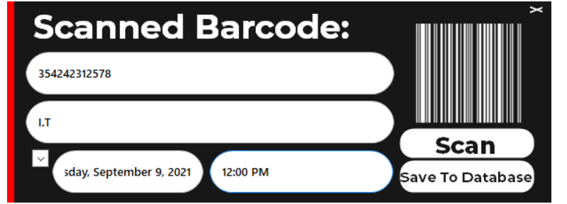SCANNNER FORM

On this particular form named Scanner Form. This is the way of the Guard or the Authorized personel who Scan every Barcode of the students that go inside the specific building. They must be scanned at first so the Security Guards can save and keep it in the Database without minding Papers to fill up.

Imports System.Data.OleDb

Imports BarcodeLib

Imports USB_Barcode_Scanner

Public Class scanAbarcode

Dim dt As DataTable = New DataTable

Public sqlString As String = ""

Dim qrCodeString As String = ""

'instantiate ConnectToDB Class

Dim connClass As ConnectToDB = New ConnectToDB

WithEvents barcodeScanner As BarcodeScanner

Private Sub scanAbarcode_Load(sender As Object, e As EventArgs) Handles MyBase.Load

barcodeScanner = New BarcodeScanner(barCodetxt)

End Sub

Private Sub barcodeScanner_BarcodeScanned(sender As Object, e As BarcodeScannerEventArgs) Handles barcodeScanner.BarcodeScanned

barCodetxt.Text = e.Barcode

End Sub

Private Sub BunifuImageButton2_Click(sender As Object, e As EventArgs) Handles BunifuImageButton2.Click

Me.Close()

End Sub

Private Sub BunifuButton2_Click(sender As Object, e As EventArgs) Handles BunifuButton2.Click

Try

Dim barcode As Barcode = New Barcode()

Dim foreColor As Color = Color.White

Dim backColor As Color = Color.Transparent

Dim image As Image = barcode.Encode(TYPE.UPCA, barCodetxt.Text, foreColor, backColor, CInt(picBcodes.Width * 0.8), CInt(picBcodes.Height * 0.8))

picBcodes.Image = image

Catch ex As Exception

MessageBox.Show(ex.Message.ToString)

End Try

End Sub

Private Sub DateTimePicker1_ValueChanged(sender As Object, e As EventArgs) Handles DateTimePicker1.ValueChanged

DateIn.Text = DateTimePicker1.Text

End Sub

Private Sub BunifuButton1_Click(sender As Object, e As EventArgs) Handles BunifuButton1.Click

Dim cmd As New OleDb.OleDbCommand

connClass.OpenConnection()

Dim sqlString As String = "INSERT INTO LogofTransac(Date_In,Time_In,Building,barCodenum) VALUES (@Date_In,@Time_In,@Building,@barCodenum)"

cmd.CommandText = sqlString

cmd.Connection = connClass.conn

cmd.Parameters.AddWithValue("@Date_In", DateIn.Text)

cmd.Parameters.AddWithValue("@Time_In", TimeIn.Text)

cmd.Parameters.AddWithValue("@Building", buildings.Text)

cmd.Parameters.AddWithValue("@barCodenum", barCodetxt.Text)

Dim r As Integer

r = cmd.ExecuteNonQuery()

cmd.Parameters.Clear()

connClass.closeCOn()

End Sub

End Class

ADMIN REGISTER FORM

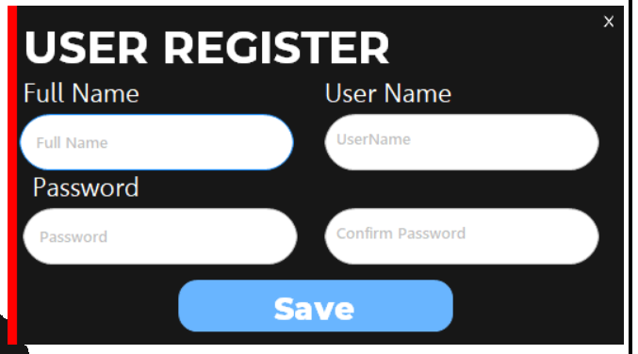

The Administrator of this Software are the only one who are authorized to have this form. It includes the Username password as well as the Full name too. Full name represents as the reference of Username and password to locate who owns the data.

Imports System.Data.OleDb

Public Class RegisterAdmin

Dim mydatarecords As DataTable = New DataTable

Dim sqlString As String = ""

Dim connClass As ConnectToDB = New ConnectToDB

Dim cmd As New OleDbCommand

Private Sub BunifuImageButton2_Click(sender As Object, e As EventArgs) Handles BunifuImageButton2.Click

Me.Close()

End Sub

Private Sub BunifuButton2_Click(sender As Object, e As EventArgs) Handles BunifuButton2.Click

Try

connClass.OpenConnection()

Dim sqlstring2 As String

sqlstring2 = "INSERT INTO adminUser (usrLogin, userpass, fullName) VALUES (@usrLogin, @userpass, @fullName)"

With cmd

.Connection = connClass.conn

.CommandText = sqlstring2

.Parameters.AddWithValue("@usrLogin", userName.Text)

.Parameters.AddWithValue("@userpass", password.Text)

.Parameters.AddWithValue("@fullName", fullName.Text)

End With

Dim r As Integer

r = cmd.ExecuteNonQuery()

connClass.closeCOn()

Catch ex As Exception

MessageBox.Show(ex.Message)

End Try

End Sub

End Class

**ADMIN USER INTERFACE**

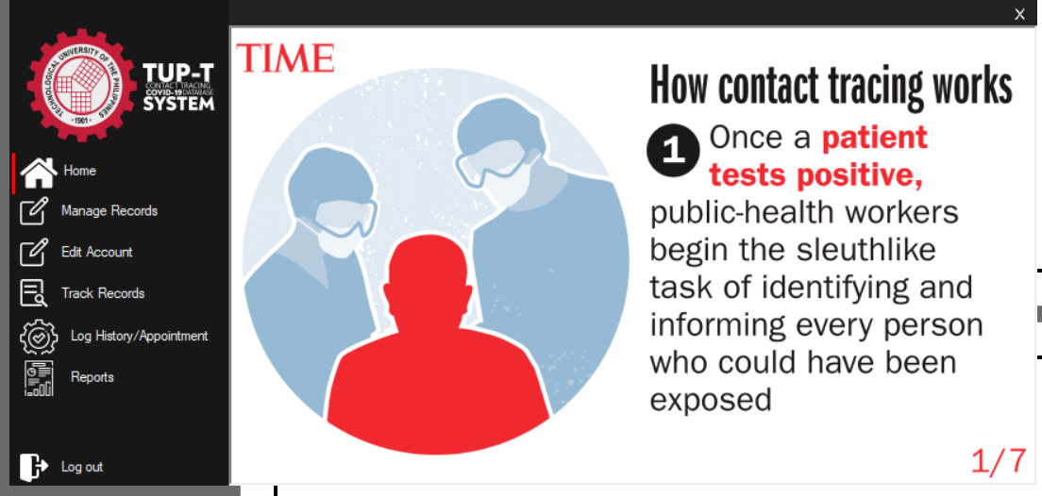

Now on the Admin Interface. It includes all of the parts of the system must have. Such as Manage Records,EditAccount,Track Records, Log History/Appointment, and Reports. The Home button represents as Animation gif that reminds us about Contact Tracing System. Manage Records stands for the Basic CRUDS of the most important Table. Edit Account is for the flexibility of the program that Administrator can change their own reference. Track records if to the people to findout easily all of their details. Log History/Appointments serves as a form that includes all of the Log History of them. Reports represent as the Crystal report of each Data.

Public Class AdminForm

Private Sub BunifuImageButton1_Click(sender As Object, e As EventArgs) Handles BunifuImageButton1.Click

Home.MdiParent = Me

Home.Dock = DockStyle.Fill

Home.Show()

End Sub

Private Sub Form2_Load(sender As Object, e As EventArgs) Handles MyBase.Load

Home.MdiParent = Me

Home.Dock = DockStyle.Fill

Home.Show()

End Sub

Private Sub Button4_Click(sender As Object, e As EventArgs) Handles Button4.Click

manageRecrd.MdiParent = Me

manageRecrd.Dock = DockStyle.Fill

manageRecrd.Show()

Panel1.Top = Button4.Top

manageRecrd.BringToFront()

End Sub

Private Sub Button6_Click(sender As Object, e As EventArgs) Handles Button6.Click

Logoutmsg.Show()

End Sub

Private Sub BunifuImageButton2_Click(sender As Object, e As EventArgs) Handles BunifuImageButton2.Click

Me.Close()

End Sub

Private Sub Button3_Click(sender As Object, e As EventArgs) Handles Button3.Click

trackRecords.MdiParent = Me

trackRecords.Dock = DockStyle.Fill

trackRecords.Show()

Panel1.Top = Button3.Top

trackRecords.BringToFront()

End Sub

Private Sub Button1_Click(sender As Object, e As EventArgs) Handles Button1.Click

Home.MdiParent = Me

Home.Dock = DockStyle.Fill

Panel1.Top = Button1.Top

Home.Show()

Home.BringToFront()

End Sub

Private Sub Button2_Click(sender As Object, e As EventArgs) Handles Button2.Click

editAccount.MdiParent = Me

editAccount.Dock = DockStyle.Fill

editAccount.Show()

Panel1.Top = Button2.Top

editAccount.BringToFront()

End Sub

Private Sub Button5_Click(sender As Object, e As EventArgs) Handles Button5.Click

logHistoryAppointment.MdiParent = Me

logHistoryAppointment.Dock = DockStyle.Fill

logHistoryAppointment.Show()

Panel1.Top = Button5.Top

logHistoryAppointment.BringToFront()

End Sub

Private Sub Button7_Click(sender As Object, e As EventArgs) Handles Button7.Click

btnReports.MdiParent = Me

btnReports.Dock = DockStyle.Fill

btnReports.Show()

Panel1.Top = Button7.Top

btnReports.BringToFront()

End Sub

End Class

**ADMIN USER INTERFACE**

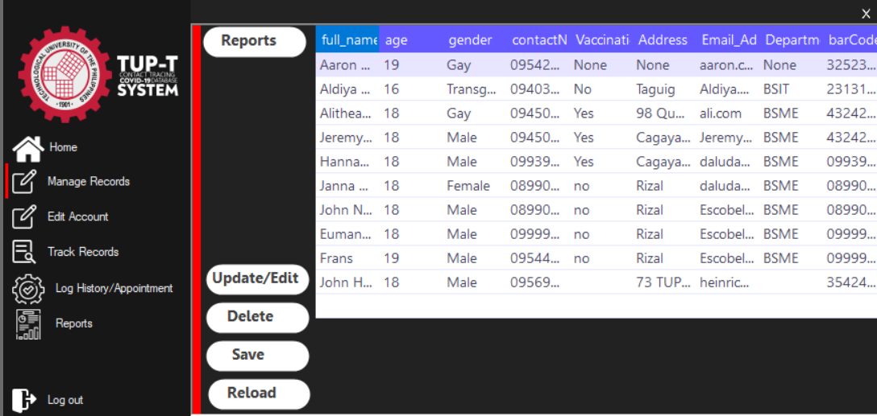

As I mentioned Earlier this represents as the Basic CRUD of the most important Table of all which is the personal details of those Users which is very confidential that’s why they are in the Admin Interface.

Imports System.Data.OleDb

Public Class manageRecrd

Dim mydatarecords As DataTable = New DataTable

Dim sqlString As String = ""

Dim connClass As ConnectToDB = New ConnectToDB

Private Sub BunifuButton4_Click(sender As Object, e As EventArgs) Handles BunifuButton4.Click

editUpdatebtn.MdiParent = AdminForm

editUpdatebtn.Dock = DockStyle.Fill

editUpdatebtn.Show()

End Sub

Private Sub manageRecrd_Load(sender As Object, e As EventArgs) Handles MyBase.Load, Refresh.Click

sqlString = "SELECT full_name, age, gender, contactNum, Vaccination_Status, Address, Email_Address, DepartmentCourse, barCodenum FROM People"

mydatarecords = connClass.selectFrom(sqlString)

GunaDataGridView1.DataSource = mydatarecords

End Sub

Private Sub BunifuButton1_Click_1(sender As Object, e As EventArgs) Handles BunifuButton1.Click

deleteButton.MdiParent = AdminForm

deleteButton.Dock = DockStyle.Fill

deleteButton.Show()

End Sub

Private Sub BunifuButton2_Click_1(sender As Object, e As EventArgs) Handles BunifuButton2.Click

insertButton.MdiParent = AdminForm

insertButton.Dock = DockStyle.Fill

insertButton.Show()

End Sub

Private Sub BunifuButton3_Click(sender As Object, e As EventArgs) Handles BunifuButton3.Click

Dim dt As New DataTable

With dt

.Columns.Add("full_name")

.Columns.Add("age")

.Columns.Add("gender")

.Columns.Add("contactNum")

.Columns.Add("Vaccination_Status")

.Columns.Add("Address")

.Columns.Add("Email_Address")

.Columns.Add("DepartmentCourse")

.Columns.Add("barCodenum")

End With

For Each dr As DataGridViewRow In Me.GunaDataGridView1.Rows

dt.Rows.Add(dr.Cells("full_name").Value, dr.Cells("age").Value, dr.Cells("gender").Value, dr.Cells("contactNum").Value, dr.Cells("Vaccination_Status").Value, dr.Cells("Address").Value, dr.Cells("DepartmentCourse").Value, dr.Cells("barCodenum").Value)

Next

Dim rptDoc As CrystalDecisions.CrystalReports.Engine.ReportDocument

rptDoc = New CrystalReport2

rptDoc.SetDataSource(dt)

Form1.CrystalReportViewer1.ReportSource = rptDoc

Form1.ShowDialog()

Form1.Dispose()

End Sub

End Class

**ADMIN USER INTERFACE**

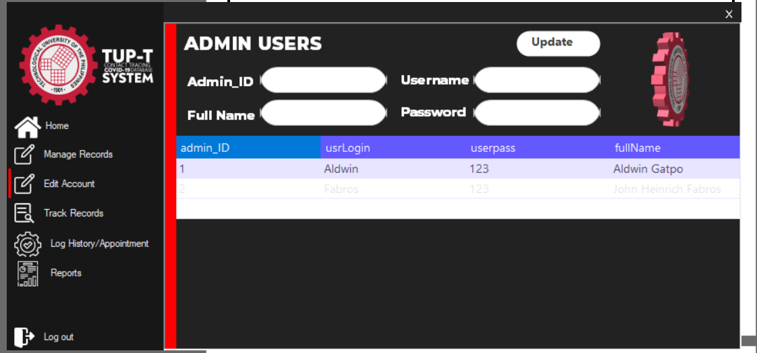

This stands for the changing of reference of the Administrator of the program.

Imports System.Data.OleDb

Public Class editAccount

Dim mydatarecords As DataTable = New DataTable

Dim sqlString As String = ""

Dim connClass As ConnectToDB = New ConnectToDB

Private Sub editAccount_Load(sender As Object, e As EventArgs) Handles MyBase.Load

sqlString = "SELECT * FROM adminUser"

mydatarecords = connClass.selectFrom(sqlString)

GunaDataGridView1.DataSource = mydatarecords

End Sub

Private Sub BunifuButton1_Click(sender As Object, e As EventArgs) Handles BunifuButton1.Click

sqlString = "UPDATE adminUser Set usrLogin = '" & userName.Text & "', userpass = '" & pasword.Text & "', fullName = '" & fullName.Text & "'"

connClass.updateFrom(sqlString)

GunaDataGridView1.DataSource = mydatarecords

sqlString = "SELECT * FROM adminUser"

mydatarecords = connClass.selectFrom(sqlString)

GunaDataGridView1.DataSource = mydatarecords

End Sub

End Class

**ADMIN USER INTERFACE**

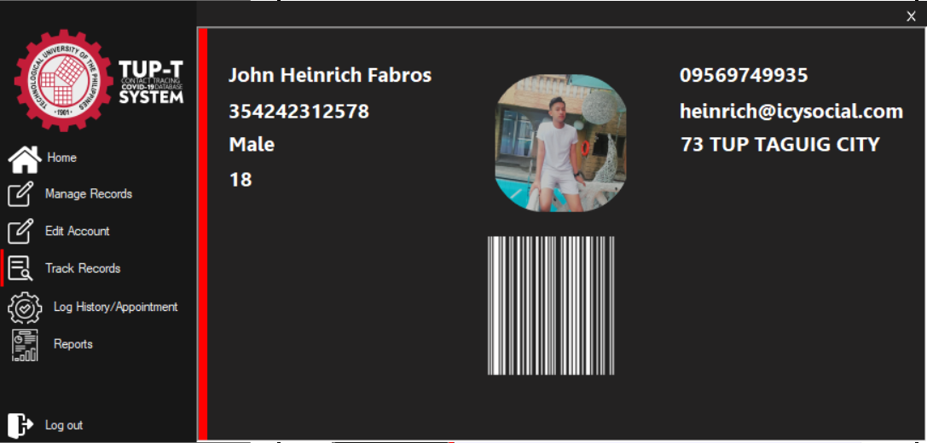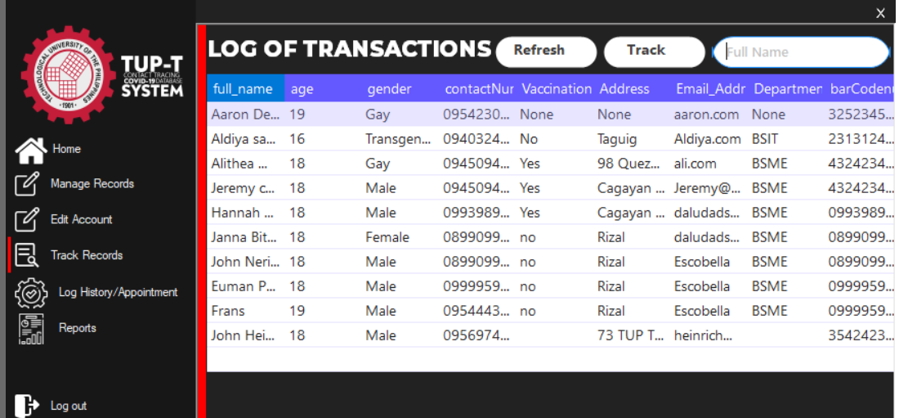

They are separated in 2 kind of forms Which as we can see that when we search a Details of User it includes all of the information and pass the Data into the another form which we can literally see all of it’s Details of a user

Imports System.Data.OleDb

Public Class trackRecords

Dim mydatarecords As DataTable = New DataTable

Dim sqlString As String = ""

Dim connClass As ConnectToDB = New ConnectToDB

Private Sub BunifuButton5_Click(sender As Object, e As EventArgs) Handles BunifuButton5.Click

Try

Dim dt As DataTable = New DataTable

dt = connClass.selectFrom("SELECT * FROM People WHERE full_Name = '" & BunifuTextBox1.Text & "'")

If dt.Rows.Count = 0 Then

MsgBox("No record found!")

Else

Tracked.MdiParent = AdminForm

Tracked.Dock = DockStyle.Fill

Tracked.sqlString = "SELECT * FROM People WHERE full_Name = '" & BunifuTextBox1.Text & "'"

Tracked.Show()

End If

Catch

End Try

End Sub

Private Sub trackRecords_Load(sender As Object, e As EventArgs) Handles MyBase.Load

sqlString = "SELECT full_name, age, gender, contactNum, Vaccination_Status, Address, Email_Address, DepartmentCourse, barCodenum FROM People"

mydatarecords = connClass.selectFrom(sqlString)

GunaDataGridView1.DataSource = mydatarecords

End Sub

End Class

Imports System.Data.OleDb

Imports BarcodeLib

Public Class Tracked

Dim dt As DataTable = New DataTable

Public sqlString As String = ""

Dim qrCodeString As String = ""

'instantiate ConnectToDB Class

Dim connClass As ConnectToDB = New ConnectToDB

Private Sub Tracked_Load(sender As Object, e As EventArgs) Handles MyBase.Load

Try

Dim arrImage() As Byte

connClass.OpenConnection()

dt = connClass.selectFrom(sqlString)

'get data from datatablt and set it to textbox fields

Label1.Text = dt.Rows(0).Item("full_name").ToString()

age.Text = dt.Rows(0).Item("age").ToString()

gender.Text = dt.Rows(0).Item("gender").ToString()

contactNum.Text = dt.Rows(0).Item("contactNum").ToString()

'vacStat.Text = dt.Rows(0).Item("Vaccination_Status").ToString()

Address.Text = dt.Rows(0).Item("Address").ToString()

EmailAdd.Text = dt.Rows(0).Item("Email_Address").ToString()

barCodenum.Text = dt.Rows(0).Item("barCodenum").ToString()

'set qrstring to barcode from database

qrCodeString = dt.Rows(0).Item("barCodenum").ToString()

arrImage = dt.Rows(0).Item("photo")

Dim mstream As New System.IO.MemoryStream(arrImage)

BunifuPictureBox1.Image = Image.FromStream(mstream)

'convert qrstringcode to actual barcode image

Dim barcode As Barcode = New Barcode()

Dim foreColor As Color = Color.White

Dim backColor As Color = Color.Transparent

Dim image2 As Image = barcode.Encode(TYPE.UPCA, qrCodeString, foreColor, backColor, CInt(PictureBox1.Width * 0.8), CInt(PictureBox1.Height * 0.8))

PictureBox1.Image = image2

Catch ex As Exception

End Try

'close connection required for every session to database

connClass.closeCOn()

End Sub

End Class

**ADMIN USER INTERFACE**

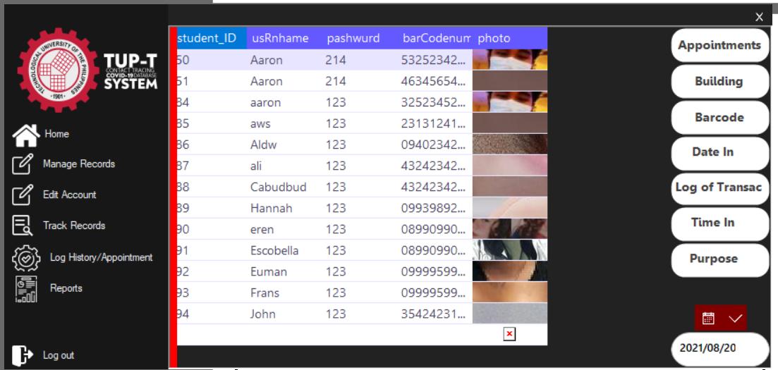

On this Interface we can see a Datagrid with a lots of button. Each button represents as as search button of what and where you wanted to see in 1 Datagrid. Let’s say we wanted to see the Date of the time of user will come in this building also comes with the Time In, Purposes Log of Transaction, Date In, Barcode, Bulding.

Imports System.Data.OleDb

Public Class logHistoryAppointment

Dim mydatarecords As DataTable = New DataTable

Dim sqlString As String = ""

Dim connClass As ConnectToDB = New ConnectToDB

Private Sub BunifuButton5_Click(sender As Object, e As EventArgs)

Try

mydatarecords = connClass.selectFrom("SELECT * FROM LogofTransac WHERE barCodenum ='" & bCode.Text & "'")

If (mydatarecords.Rows.Count > 0) Then

Dgrid1.DataSource = mydatarecords

Else

MessageBox.Show("Not Found!")

End If

Catch ex As Exception

MsgBox("Error in collecting data from Database. Error is :" & ex.Message)

End Try

End Sub

Private Sub logHistory_Load(sender As Object, e As EventArgs) Handles MyBase.Load

sqlString = "SELECT * FROM LogofTransac"

mydatarecords = connClass.selectFrom(sqlString)

Dgrid1.DataSource = mydatarecords

End Sub

Private Sub BunifuButton1_Click(sender As Object, e As EventArgs)

sqlString = "SELECT * FROM StudentAppointment"

mydatarecords = connClass.selectFrom(sqlString)

Dgrid1.DataSource = mydatarecords

End Sub

Private Sub BunifuButton2_Click(sender As Object, e As EventArgs)

sqlString = "SELECT * FROM LogofTransac"

mydatarecords = connClass.selectFrom(sqlString)

Dgrid1.DataSource = mydatarecords

End Sub

Private Sub BunifuButton3_Click(sender As Object, e As EventArgs)

Try

mydatarecords = connClass.selectFrom("SELECT * FROM StudentAppointment WHERE Building ='" & bCode.Text & "'")

If (mydatarecords.Rows.Count > 0) Then

Dgrid1.DataSource = mydatarecords

Else

MessageBox.Show("Not Found!")

End If

Catch ex As Exception

MsgBox("Error in collecting data from Database. Error is :" & ex.Message)

End Try

End Sub

Private Sub BunifuButton4_Click(sender As Object, e As EventArgs)

Try

mydatarecords = connClass.selectFrom("SELECT * FROM StudentAppointment WHERE DateIn ='" & bCode.Text & "'")

If (mydatarecords.Rows.Count > 0) Then

Dgrid1.DataSource = mydatarecords

Else

MessageBox.Show("Not Found!")

End If

Catch ex As Exception

MsgBox("Error in collecting data from Database. Error is :" & ex.Message)

End Try

End Sub

Private Sub BunifuButton6_Click(sender As Object, e As EventArgs)

Try

mydatarecords = connClass.selectFrom("SELECT * FROM StudentAppointment WHERE TimeIn ='" & bCode.Text & "'")

If (mydatarecords.Rows.Count > 0) Then

Dgrid1.DataSource = mydatarecords

Else

MessageBox.Show("Not Found!")

End If

Catch ex As Exception

MsgBox("Error in collecting data from Database. Error is :" & ex.Message)

End Try

End Sub

Private Sub BunifuButton7_Click(sender As Object, e As EventArgs)

Try

mydatarecords = connClass.selectFrom("SELECT * FROM StudentAppointment WHERE purpose ='" & bCode.Text & "'")

If (mydatarecords.Rows.Count > 0) Then

Dgrid1.DataSource = mydatarecords

Else

MessageBox.Show("Not Found!")

End If

Catch ex As Exception

MsgBox("Error in collecting data from Database. Error is :" & ex.Message)

End Try

End Sub

Private Sub BunifuDatepicker1_onValueChanged(sender As Object, e As EventArgs) Handles BunifuDatepicker1.onValueChanged

Try

bCode.Text = Format(BunifuDatepicker1.Value, "yyyy/MM/dd")

Catch ex As Exception

End Try

End Sub

Private Sub BunifuButton8_Click(sender As Object, e As EventArgs) Handles BunifuButton8.Click

sqlString = "SELECT * FROM StudentAppointment"

mydatarecords = connClass.selectFrom(sqlString)

Dgrid1.DataSource = mydatarecords

End Sub

Private Sub BunifuButton12_Click(sender As Object, e As EventArgs) Handles BunifuButton12.Click

sqlString = "SELECT * FROM LogofTransac"

mydatarecords = connClass.selectFrom(sqlString)

Dgrid1.DataSource = mydatarecords

End Sub

Private Sub BunifuButton9_Click(sender As Object, e As EventArgs) Handles BunifuButton9.Click

Try

mydatarecords = connClass.selectFrom("SELECT * FROM StudentAppointment WHERE Building ='" & bCode.Text & "'")

If (mydatarecords.Rows.Count > 0) Then

Dgrid1.DataSource = mydatarecords

Else

MessageBox.Show("Not Found!")

End If

Catch ex As Exception

MsgBox("Error in collecting data from Database. Error is :" & ex.Message)

End Try

End Sub

Private Sub BunifuButton10_Click(sender As Object, e As EventArgs) Handles BunifuButton10.Click

Try

mydatarecords = connClass.selectFrom("SELECT * FROM LogofTransac WHERE barCodenum ='" & bCode.Text & "'")

If (mydatarecords.Rows.Count > 0) Then

Dgrid1.DataSource = mydatarecords

Else

MessageBox.Show("Not Found!")

End If

Catch ex As Exception

MsgBox("Error in collecting data from Database. Error is :" & ex.Message)

End Try

End Sub

Private Sub BunifuButton11_Click(sender As Object, e As EventArgs) Handles BunifuButton11.Click

Try

mydatarecords = connClass.selectFrom("SELECT * FROM StudentAppointment WHERE DateIn ='" & bCode.Text & "'")

If (mydatarecords.Rows.Count > 0) Then

Dgrid1.DataSource = mydatarecords

Else

MessageBox.Show("Not Found!")

End If

Catch ex As Exception

MsgBox("Error in collecting data from Database. Error is :" & ex.Message)

End Try

End Sub

Private Sub BunifuButton13_Click(sender As Object, e As EventArgs) Handles BunifuButton13.Click

Try

mydatarecords = connClass.selectFrom("SELECT * FROM StudentAppointment WHERE TimeIn ='" & bCode.Text & "'")

If (mydatarecords.Rows.Count > 0) Then

Dgrid1.DataSource = mydatarecords

Else

MessageBox.Show("Not Found!")

End If

Catch ex As Exception

MsgBox("Error in collecting data from Database. Error is :" & ex.Message)

End Try

End Sub

Private Sub BunifuButton14_Click(sender As Object, e As EventArgs) Handles BunifuButton14.Click

Try

mydatarecords = connClass.selectFrom("SELECT * FROM StudentAppointment WHERE purpose ='" & bCode.Text & "'")

If (mydatarecords.Rows.Count > 0) Then

Dgrid1.DataSource = mydatarecords

Else

MessageBox.Show("Not Found!")

End If

Catch ex As Exception

MsgBox("Error in collecting data from Database. Error is :" & ex.Message)

End Try

End Sub

End Class

**ADMIN USER INTERFACE**

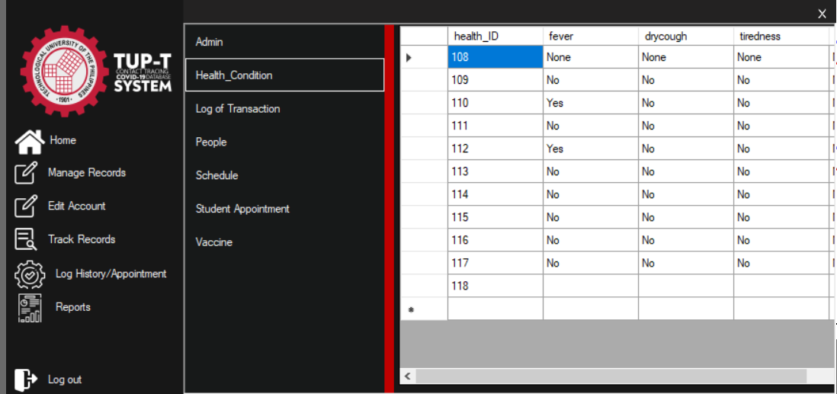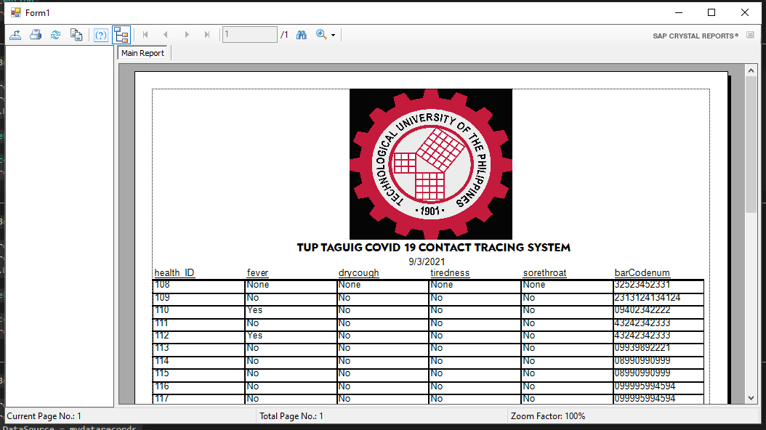

In this part you will see a Crystal report and the Buttons. Each button represents as a whole details of a table we wanted to confirm at the Datagrid and pass the values in the Crystal Report. The main purpose of Crystal Reports is to allow users to pull their desired data from a data source, such as an Oracle or MS SQL Server database, and present the data in a repeatable and organized way.

Imports System.Data.OleDb

Public Class btnReports

Dim mydatarecords As DataTable = New DataTable

Dim sqlString As String = ""

Dim connClass As ConnectToDB = New ConnectToDB

Private Sub Button1_Click(sender As Object, e As EventArgs) Handles Button1.Click

sqlString = "SELECT * FROM adminUser"

mydatarecords = connClass.selectFrom(sqlString)

DataGridView1.DataSource = mydatarecords

Dim dt As New DataTable

With dt

.Columns.Add("admin_ID")

.Columns.Add("usrLogin")

.Columns.Add("userpass")

.Columns.Add("fullName")

End With

For Each dr As DataGridViewRow In Me.DataGridView1.Rows

dt.Rows.Add(dr.Cells("admin_ID").Value, dr.Cells("usrLogin").Value, dr.Cells("userpass").Value, dr.Cells("fullName").Value)

Next

Dim rptDoc As CrystalDecisions.CrystalReports.Engine.ReportDocument

rptDoc = New CrystalReport3

rptDoc.SetDataSource(dt)

Form1.CrystalReportViewer1.ReportSource = rptDoc

Form1.ShowDialog()

Form1.Dispose()

End Sub

Private Sub Button2_Click(sender As Object, e As EventArgs) Handles Button2.Click

sqlString = "SELECT * FROM Health_Condition"

mydatarecords = connClass.selectFrom(sqlString)

DataGridView1.DataSource = mydatarecords

Dim dt As New DataTable

With dt

.Columns.Add("health_ID")

.Columns.Add("fever")

.Columns.Add("drycough")

.Columns.Add("tiredness")

.Columns.Add("sorethroat")

.Columns.Add("barCodenum")

End With

For Each dr As DataGridViewRow In Me.DataGridView1.Rows

dt.Rows.Add(dr.Cells("health_ID").Value, dr.Cells("fever").Value, dr.Cells("drycough").Value, dr.Cells("tiredness").Value, dr.Cells("sorethroat").Value, dr.Cells("barCodenum").Value)

Next

Dim rptDoc As CrystalDecisions.CrystalReports.Engine.ReportDocument

rptDoc = New CrystalReport4

rptDoc.SetDataSource(dt)

Form1.CrystalReportViewer1.ReportSource = rptDoc

Form1.ShowDialog()

Form1.Dispose()

End Sub

Private Sub Button4_Click(sender As Object, e As EventArgs) Handles Button4.Click

sqlString = "SELECT * FROM People"

mydatarecords = connClass.selectFrom(sqlString)

DataGridView1.DataSource = mydatarecords

Dim dt As New DataTable

With dt

.Columns.Add("full_name")

.Columns.Add("age")

.Columns.Add("gender")

.Columns.Add("contactNum")

.Columns.Add("Vaccination_Status")

.Columns.Add("Address")

.Columns.Add("Email_Address")

.Columns.Add("DepartmentCourse")

.Columns.Add("barCodenum")

End With

For Each dr As DataGridViewRow In Me.DataGridView1.Rows

dt.Rows.Add(dr.Cells("full_name").Value, dr.Cells("age").Value, dr.Cells("gender").Value, dr.Cells("contactNum").Value, dr.Cells("Vaccination_Status").Value, dr.Cells("Address").Value, dr.Cells("DepartmentCourse").Value, dr.Cells("barCodenum").Value)

Next

Dim rptDoc As CrystalDecisions.CrystalReports.Engine.ReportDocument

rptDoc = New CrystalReport2

rptDoc.SetDataSource(dt)

Form1.CrystalReportViewer1.ReportSource = rptDoc

Form1.ShowDialog()

Form1.Dispose()

End Sub

Private Sub Button5_Click(sender As Object, e As EventArgs) Handles Button5.Click

sqlString = "SELECT * FROM schedule"

mydatarecords = connClass.selectFrom(sqlString)

DataGridView1.DataSource = mydatarecords

Dim dt As New DataTable

With dt

.Columns.Add("schedule_ID")

.Columns.Add("name")

.Columns.Add("purpose")

.Columns.Add("dateofSched")

.Columns.Add("barCodenum")

.Columns.Add("timeIn")

End With

For Each dr As DataGridViewRow In Me.DataGridView1.Rows

dt.Rows.Add(dr.Cells("schedule_ID").Value, dr.Cells("name").Value, dr.Cells("purpose").Value, dr.Cells("dateofSched").Value, dr.Cells("barCodenum").Value, dr.Cells("timeIn").Value)

Next

Dim rptDoc As CrystalDecisions.CrystalReports.Engine.ReportDocument

rptDoc = New CrystalReport5

rptDoc.SetDataSource(dt)

Form1.CrystalReportViewer1.ReportSource = rptDoc

Form1.ShowDialog()

Form1.Dispose()

End Sub

Private Sub Button6_Click(sender As Object, e As EventArgs) Handles Button6.Click

sqlString = "SELECT * FROM StudentAppointment"

mydatarecords = connClass.selectFrom(sqlString)

DataGridView1.DataSource = mydatarecords

Dim dt As New DataTable

With dt

.Columns.Add("student_ID")

.Columns.Add("usRnhame")

.Columns.Add("pashwurd")

.Columns.Add("barCodenum")

End With

For Each dr As DataGridViewRow In Me.DataGridView1.Rows

dt.Rows.Add(dr.Cells("student_ID").Value, dr.Cells("usRnhame").Value, dr.Cells("pashwurd").Value, dr.Cells("barCodenum").Value)

Next

Dim rptDoc As CrystalDecisions.CrystalReports.Engine.ReportDocument

rptDoc = New CrystalReport6

rptDoc.SetDataSource(dt)

Form1.CrystalReportViewer1.ReportSource = rptDoc

Form1.ShowDialog()

Form1.Dispose()

End Sub

Private Sub Button7_Click(sender As Object, e As EventArgs) Handles Button7.Click

sqlString = "SELECT * FROM Vaccine"

mydatarecords = connClass.selectFrom(sqlString)

DataGridView1.DataSource = mydatarecords

Dim dt As New DataTable

With dt

.Columns.Add("vaccine_ID")

.Columns.Add("vaccineCategory")

.Columns.Add("vaccineStatus")

.Columns.Add("barCodenum")

End With

For Each dr As DataGridViewRow In Me.DataGridView1.Rows

dt.Rows.Add(dr.Cells("vaccine_ID").Value, dr.Cells("vaccineCategory").Value, dr.Cells("vaccineStatus").Value, dr.Cells("barCodenum").Value)

Next

Dim rptDoc As CrystalDecisions.CrystalReports.Engine.ReportDocument

rptDoc = New CrystalReport7

rptDoc.SetDataSource(dt)

Form1.CrystalReportViewer1.ReportSource = rptDoc

Form1.ShowDialog()

Form1.Dispose()

End Sub

End Class

**LOG OUT FORM**

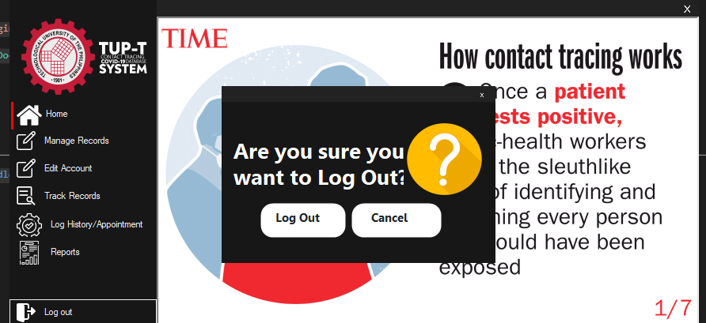

The log out form is the function to confirm the user if they want to log out and cancel and go back to the Program. This also to prevent the mislick of the moue in the log out button.

Public Class Logoutmsg

Private Sub BunifuButton1_Click(sender As Object, e As EventArgs) Handles lgu.Click

Me.Hide()

AdminForm.Hide()

guiLogin.Show()

End Sub

Private Sub BunifuButton2_Click(sender As Object, e As EventArgs) Handles BunifuButton2.Click

Me.Close()

End Sub

Private Sub BunifuImageButton2_Click(sender As Object, e As EventArgs) Handles BunifuImageButton2.Click

Me.Close()

End Sub

End Class

**USER STUDENT FORM**

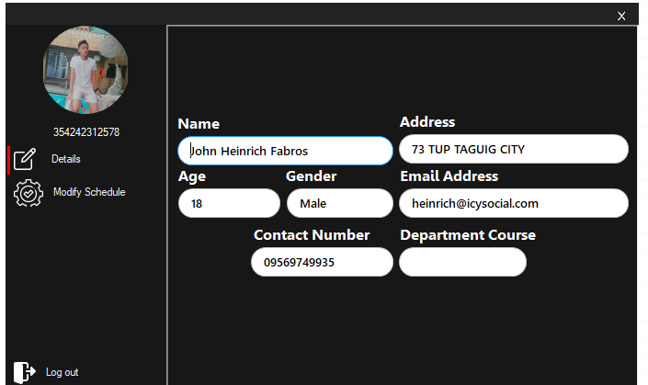

This user form has to do with the details and the Schedule appointment of the specified user that Logged In in the LogIn form. It simplifies the cancellation of appointment throuth the barCodenumber because passing of barcodenumber will set the parameters to pass the value in the other form so in the other form can detect whom the unique barcode is this and all of the details belongs with the Barcode are counted in the Output.

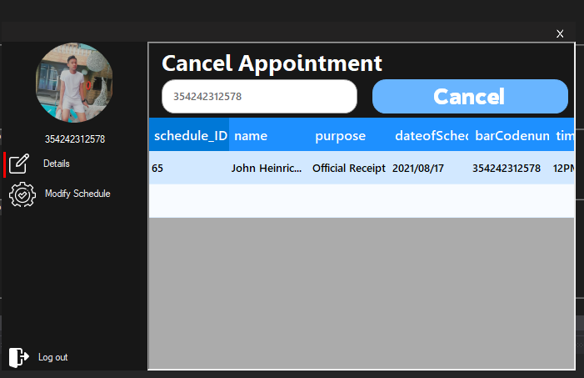Cancellation of appointment can only be done once we clicked the Cancel button so the numbers of slots in the Registration form will regain the numbers back into 0.

Imports System.Data.OleDb

Imports BarcodeLib

Imports System.IO

Public Class UserForm

Dim dt As DataTable = New DataTable

Dim dx As DataTable = New DataTable

Public sqlString As String = ""

Public sqlString1 As String = ""

Dim qrCodeString As String = ""

'instantiate ConnectToDB Class

Dim connClass As ConnectToDB = New ConnectToDB

Private Sub LOGINstudentAPPOINTMENT_Load(sender As Object, e As EventArgs) Handles MyBase.Load

Try

Dim arrImage() As Byte

connClass.OpenConnection()

dt = connClass.selectFrom(sqlString)

dx = connClass.selectFrom(sqlString1)

arrImage = dt.Rows(0).Item("photo")

Dim mstream As New System.IO.MemoryStream(arrImage)

BunifuPictureBox1.Image = Image.FromStream(mstream)

Label1.Text = dx.Rows(0).Item("barCodenum").ToString()

userDetails.MdiParent = Me

userDetails.Dock = DockStyle.Fill

userDetails.Show()

Catch ex As Exception

End Try

connClass.closeCOn()

End Sub

Private Sub BunifuButton1_Click(sender As Object, e As EventArgs)

userDetails.MdiParent = Me

userDetails.Dock = DockStyle.Fill

userDetails.Show()

End Sub

Private Sub Button4_Click(sender As Object, e As EventArgs) Handles Button4.Click

userDetails.MdiParent = Me

userDetails.Dock = DockStyle.Fill

userDetails.Show()

End Sub

Private Sub Button5_Click(sender As Object, e As EventArgs) Handles Button5.Click

USEReditacc.MdiParent = Me

USEReditacc.Dock = DockStyle.Fill

USEReditacc.StringPass = Label1.Text

USEReditacc.Show()

End Sub

End Class

Imports System.Data.OleDb

Public Class USEReditacc

Dim cmd As New OleDbCommand

Dim mydatarecords As DataTable = New DataTable

Dim sqlString As String = ""

Dim connClass As ConnectToDB = New ConnectToDB

Public Property StringPass As String

Private Sub BunifuButton1_Click(sender As Object, e As EventArgs) Handles BunifuButton1.Click

cmd.Connection = connClass.conn

connClass.OpenConnection()

Dim sqlString1 As String = "DELETE FROM schedule WHERE barCodenum = @ID"

With cmd

.Connection = connClass.conn

.CommandText = sqlString1

.Parameters.AddWithValue("@ID", UserForm.Label1.Text)

End With

Dim r As Integer

r = cmd.ExecuteNonQuery()

mydatarecords = connClass.selectFrom("SELECT * FROM schedule WHERE barCodenum ='" & UserForm.Label1.Text & "'")

If (mydatarecords.Rows.Count > 0) Then

DataGridView1.DataSource = mydatarecords

connClass.closeCOn()

End If

End Sub

Private Sub USEReditacc_Load(sender As Object, e As EventArgs) Handles MyBase.Load

bcode.Text = StringPass

Try

mydatarecords = connClass.selectFrom("SELECT * FROM schedule WHERE barCodenum ='" & bcode.Text & "'")

If (mydatarecords.Rows.Count > 0) Then

DataGridView1.DataSource = mydatarecords

Else

MessageBox.Show("Not Found!")

End If

Catch ex As Exception

MsgBox("Error in collecting data from Database. Error is :" & ex.Message)

End Try

End Sub

End Class

**THAT’S ALL FOR NOW**

**THANK YOU FOR TIME AND EFFORT**

**MAY GOD BLESS YOU!**